Strategic Innovation and Business Transformation: Bridging Technology, Leadership, and Global Impact

Aavula Akshainie Sri¹, Ango Rithika², Anisha P R³, Kishor Kumar Reddy C⁴

^{1,2}Research Intern

^{3,4}Department of Computer Science and Engineering

¹Botswana Botho University, Botswana

²University of South Alabama, USA

^{3,4}Stanley College of Engineering and Technology for Women, India

ABSTRACT

This book chapter deals with Strategic Innovation and Business Transformation: Bridging Technology, Leadership, and Global Impact. It ponders how companies can innovate strategically and fundamentally transform their operational processes to exist in a rapidly changing environment. It describes the converging emerging technologies like AI, IoT, blockchain, and cloud computing that make digital transformation and business agility viable. The book elaborates on how visionary and transformational leadership builds a culture of innovation to initiate change with mediation towards the alignment of the organization to strategic goals. It focuses on sustainability and global impact in terms of ESG objectives and inclusive innovation that meets the needs of developing economies. Common barriers faced in the process include resistance to change, technology integration, and cultural differences. Yet, these might be overcome by working cross-functionally, engaging in continuous learning, and focusing on performance measurement. The chapter also comprehensively provides strategic frameworks and transformation models that guide businesses in achieving alignment between innovation and long-term value creation. Real-world case studies from banking, healthcare, and manufacturing show applications of the process and lessons learned. Wrapping up with trends and leadership imperatives, the chapter offers a holistic view of how technology, leadership, and sustainability must come together to enable successful business transformation that makes lasting global impact on society.
Keywords: Artificial Intelligence, Business Transformation, Emerging Technologies, Innovation Strategy, Leadership, Sustainability

1.Introduction
The impact of AI is no longer limited to advanced research facilities or tech-centric firms. Its influence is now deeply felt in the digital transformation of entrepreneurial leadership and innovation. Small businesses and start-ups are under immense pressure to not only keep pace with established players, but to also master the art of using new disruptive digital technologies. AI stands out amongst these technologies for its ability to re-imagine decision-making processes, cut down on operational inefficiencies, and open the doors to unexplained business avenues.

The combination of meaningful and timely data, market insight, and judgment from a seasoned human has been the hallmark of successful entrepreneurial leadership. Notably, the focus on leveraging AI in strict entrepreneurial approaches appears disjoint and reason-based, even when its advantages are widely acknowledged. Emerging entrepreneurs now face the opportunity and challenge dealing with this strategic adoption and awareness gap.

The purpose of this chapter is to explore how AI can be integrated into entrepreneurial ventures to serve as a central driver of innovation and growth, as opposed to simply being a technical add-on. In particular, this chapter aims to discuss frameworks for AI adoption, ethical and human-centric considerations, and implications for future leadership in AI-enabled economies, along with real-world case studies of successful ventures. The purpose of this chapter is to offer entrepreneurs a roadmap for how to leverage AI, not as a tool, but as a fundamental element of business strategy, by integrating and addressing the different angles of strategic AI integration.

  - Understanding AI and its Relevance to Entrepreneurship

Artificial Intelligence (AI) is now one of the most powerful facilitators of entrepreneurial action within the digital economy. Essentially, AI describes computing systems that are able to simulate human intelligence by learning, reasoning, and correcting themselves. For entrepreneurs, this entails using the likes of natural language processing, computer vision, and machine learning to develop more intelligent products and services. The value of AI is in how it supports business ventures in transcending the constraints of scale and resource by facilitating predictive intelligence, automation, and personalization. Startups, for instance, can leverage AI to understand consumer behavior, maximize marketing efforts, and automate supply chain management — all significant in highly competitive markets. Researchers observe that AI incorporation enables entrepreneurs to make more informed decisions and innovate at high speed, turning it into a survival and growth strategy for navigating unpredictable business landscapes.

Further, the contribution of AI to entrepreneurship goes beyond the efficiency of operations to influencing the very definition of leadership and innovation. Entrepreneurs today are not merely required to discover opportunities in the market but also to incorporate intelligent technologies into the very fabric of their strategies. This needs a dual perspective: grasping the technical capabilities of AI and how to align it with human imagination and market demand. For example, generative AI tools currently help entrepreneurs prototype new concepts, forecast consumer behavior, and even model various business scenarios before investing resources. By integrating AI into the core of entrepreneurial endeavors, leaders can grow their businesses more quickly, minimize risks, and tap into global opportunities. Therefore, the applicability of AI to entrepreneurship is technological as well as strategic, and it is a must-have companion for business leaders who aspire to succeed in the age of digital disruption.

1.1 📊 Table 1 : Key Applications of AI in Entrepreneurship

Application Area | AI Technology Used | Impact on Entrepreneurship
Customer Engagement | Chatbots, NLP | Personalized service, 24/7 support
Market Analysis | Machine Learning, Big Data | Predictive insights, trend identification
Product Development | Generative AI, Deep Learning | Faster prototyping, innovation
Operations & Supply Chain | Computer Vision, AI Optimization | Cost reduction, efficiency
Risk Management | Predictive Analytics | Better decision-making, reduced uncertainty
Table 1 provides an overview of the primary areas where AI technologies are transforming entrepreneurial practices. As shown in Table 1, customer engagement is enhanced through chatbots and natural language processing (NLP), which allow for personalized services and 24/7 interaction. Market analysis benefits from machine learning and big data, enabling predictive insights and identification of emerging trends. Generative AI and deep learning speed up product development with quicker prototyping and innovation. Computer vision and AI-optimization optimize operations and supply chains, resulting in cost savings and enhanced efficiency. Lastly, predictive analytics serves as a key to managing risk by enabling entrepreneurs to make smarter decisions while minimizing uncertainty. This table illustrates the wide generalizability of AI to various dimensions of business, showing its ability to both improve efficiency and innovation in startups.

1.2 Emergence of Entrepreneurial Leadership in the Digital Age

The digital age has radically transformed the expectation of entrepreneurial leadership. As opposed to conventional leaders who primarily concerned themselves with resource distribution and hierarchical management, contemporary entrepreneurial leaders need to operate in a highly dynamic context characterized by technological change, digital disruption, and global competition. Leadership in such a context calls for agility, adaptability, and a robust orientation towards innovation. Artificial Intelligence (AI) accelerates this change by providing leaders with real-time information, predictive analytics, and automation capabilities that enable them to react to new market requirements at the speed of thought. Researchers point out that entrepreneurial leadership in the digital world is now less about resource management but more about strategically deploying digital technologies such as AI to create sustainable value and competitive edge (Brynjolfsson & McAfee, 2017).

In addition, the emergence of entrepreneurial leadership during this age is directly correlated to technological democratization. With access to cloud-based AI software, cost-effective data platforms, and open-source technology, even micro-scale entrepreneurs can keep pace with conventional corporations. This has fostered a new generation of "digital-native" entrepreneurs who build technology into their business models from the very start. The outcome is a model of leadership that is less top-down, more teamwork-oriented, and very data-driven. Leaders who adopt AI-facilitated ecosystems create cultures for ongoing learning, testing, and inventiveness, which are essential for survival in the rapid digital economy. Entrepreneurial leadership has thus shifted from intuitive decision-making to an evidence-based and technology-enhanced model for determining success in the digital era (Nambisan, 2017).

1.2 📊 Table 2 :Key Differences Between Traditional and Digital-Era Entrepreneurial Leadership

Aspect | Traditional Leadership | Digital-Era Leadership (AI-Driven)
Decision-Making | Intuition, experience-based | Data-driven, predictive analytics
Leadership Style | Hierarchical, top-down | Collaborative, agile, adaptive
Innovation Approach | Incremental, resource-limited | Disruptive, tech-enabled, scalable
Market Engagement | Local/regional focus | Global reach via digital platforms
Technology Integration | Minimal or supporting role | Core driver of strategy and growth
Table 2 identifies the essential contrasts between analog entrepreneurial leadership and digital-age leadership influenced by AI technologies. As indicated by Table 2, analog decision-making is primarily driven by intuition and past experience, while AI-based leadership is more dependent on data analysis and predictive modeling to guarantee accuracy and foresight. Leadership has also changed from hierarchical, top-down styles to more collaborative and adaptive models that foster agility. In the same vein, innovation used to be incremental and resource-constrained, whereas in today's digital age, it is disruptive, technology-driven, and scalable. Engagement in the marketplace has grown from regional or local-scale operations to reaching worldwide through digital platforms. Lastly, technology has changed from being a supplementary element in conventional leadership to being the key force behind entrepreneurial expansion and strategy. This contrast illustrates how the age of technology, driven by AI, has transformed leadership strategies to address the needs of a fast-paced business world.

- Evolution of Entrepreneurial Leadership in the Digital Age

From the beginning, the landscape of entrepreneurial leadership has been marked by innovation, change, and with the ability to take advantage of new-age opportunities. Such leadership qualities, with the onset of AI, have gone through a profound mutation. Early entrepreneurs have toyed with data analyses for some decisions. In contrast, modern-day leadership is set to incorporate predictive analytics, natural language processing, and generative AI into their business planning. Evidently, there is a metamorphosis from an intuition-driven entrepreneurial activity to decision models where AI enhances decision-making concerning risk-taking. Scholars hold the view that AI-driven entrepreneurial leadership is no longer a choice; rather, it is a necessity, given the demand from digital ecosystems for agility, foresight, and resilience. AI-enabled leadership sits somewhere in the middle of the spectrum, between the extremes of leveraging complete automation to achieve efficiency versus a full human-centered.

2.1 Early AI Adoption in Startups

In the early stages of AI diffusion, business founders approached integration cautiously, undertaking small-scale implementations such as chatbots, automation tools, or customer service platforms. Pilot implementations were more often feasibility tests rather than efforts at bringing mass impact. Even then, entrepreneurial leaders perceived that AI had the potential to drive efficiency and enable one-of-a-kind customer experiences setting them apart from others (J.P. Morgan, 2023).

As adoption increased, startups began to move from testing with AI to implementing AI in their business models. Investors began to increasingly invest in businesses with quantifiable AI capabilities, which drove innovation across sectors. For instance, early adoption of AI in fintech and retail illustrated how small businesses could change the way traditional industry players did things by harnessing data and predictive analytics. These examples illustrate how early adoption created the ground for the popular adoption of AI in entrepreneurship today (Menlo Ventures, 2023).

2.2 Transformative Role of AI in Modern Strategy

The contemporary role of AI in business strategy is transformative, propelling competition away from standard levers of pricing and marketing to innovation in algorithms and data. Founders increasingly compete based on the capability to leverage machine learning and predictive models to provide quicker insights and singular value propositions. This has transformed leadership priorities, ensuring technological integration is at the heart of strategic decision-making (The New Yorker, 2023).

Concurrently, strategic adoption of AI is not an easy task. Startups have to make sure that adoption at the strategic level is in line with the organizational vision, capabilities of resources, and market opportunities. Case studies point out that ventures integrating AI at the strategic level achieve faster scalability and greater customer connectivity, demonstrating that AI is both an enabler and a disruptor of entrepreneurial success (Kaufman Rossin, 2023).

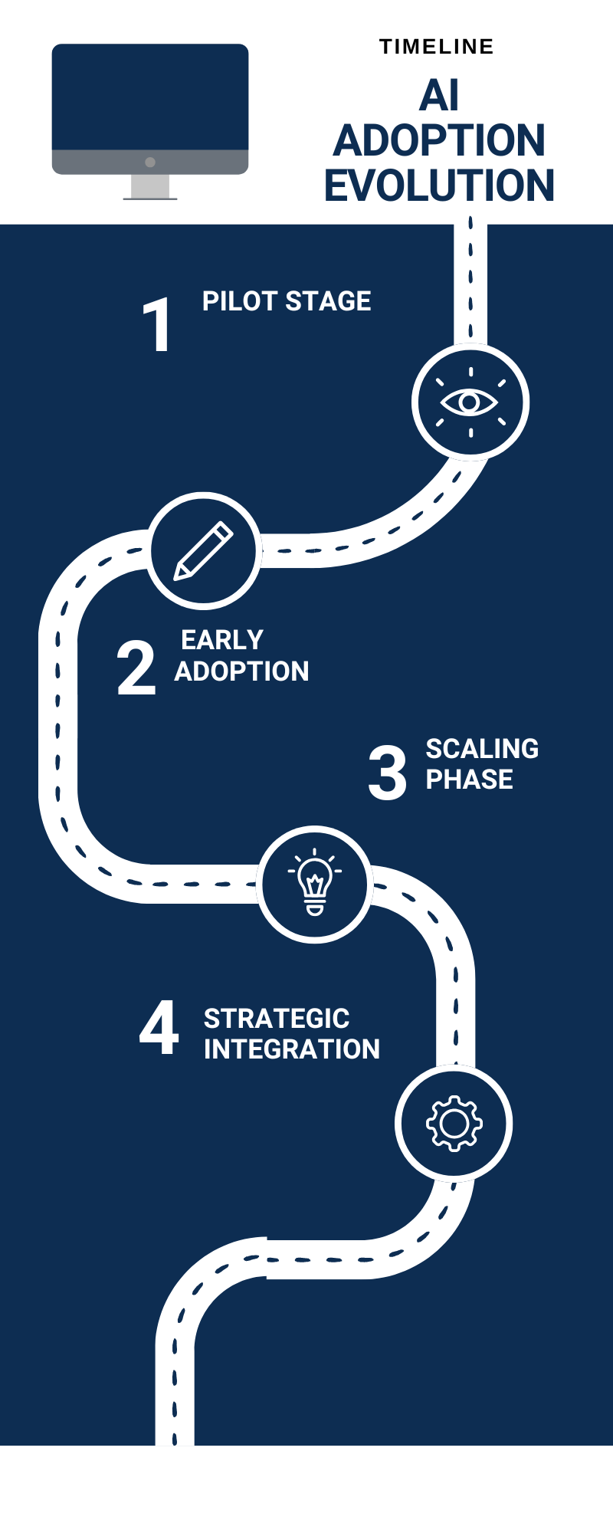
Fig 1: 2.2 Startups' AI Adoption Evolution

Figure 1 depicts the incremental process of AI adoption among startups, starting with the pilot phase where small-scale experiments are undertaken to analyze feasibility and results. It is then followed by the early adoption phase, where AI is applied in limited aspects to enhance efficiency and innovation. The scaling phase follows, where in AI-based solutions are scaled throughout business operations to create measurable effects. Lastly, the strategic integration stage is the stage where AI is a central part of long-term business strategy. As depicted in Fig. 1, this incremental process outlines how startups are transitioning from exploratory use cases to infusing AI as an integral force behind competitiveness and growth sustainability.

- Fundamentals of AI for Entrepreneurs: Challenges and Opportunities

To effectively use AI in entrepreneurial practice, first the leaders need to understand its basic concepts, tools, and applications. AI for entrepreneurs is less about the technical detailed end of things and more about being able to picture, for instance, how something like machine learning, computer vision, or NLP (natural language processing) would add value to the consideration of a business model. With these fundamentals, entrepreneurs will be in a position to search for opportunities where leveraging AI can spur innovation-from creating an automated customer service process through chatbots to setting up a predictive electromagnetic forecasting system in supply chain arenas. Equally, the understanding of challenges might bring to light such impediments as high costs, risk of data privacy violation, and scarcity of the required skills for strategic adoption. In short, by learning these basics, entrepreneurs will be able to walk through the complex maze of AI integration and concentrate on crafting a vision with which AI would harmonize. As human-centered AI frameworks stress, the objective is certainly not to replace human judgment while making an entrepreneurial choice but rather to empower entrepreneurial decisions and make them more resilient in uncertain markets.

  - Key AI Technologies Relevant to Entrepreneurs

Today's entrepreneurs depend upon an ensemble of AI technologies that vary from machine learning algorithms to natural language processing and computer vision. Such tools enable startups to automate decision-making, analyze customer trends, and streamline workflows in real time. For instance, NLP-powered chatbots augment customer care, while predictive algorithms predict demand, minimizing operational risks. By using these technologies together, entrepreneurs can use data-driven insights to make more intelligent strategic decisions (Kraus et al., 2022).

In addition to mere applications, AI technologies facilitate innovation in industries such as finance, healthcare, and e-commerce. Business owners may use AI-based recommendation engines to offer targeted customer experiences or leverage computer vision in farming to maximize yield. The above examples signify that AI technologies not only grant efficiency but also ingenuity in business model innovation (Harvard Business School Online, 2023).

3.1 📊 Table 3 : Key AI Technologies Relevant to Entrepreneurs

AI Technology | Application in Startups | Example Use Case
Machine Learning | Predictive modeling, risk analysis | Credit scoring in fintech
Natural Language Processing | Customer service, sentiment analysis | AI chatbots for customer queries
Computer Vision | Image/video analysis | Quality checks in manufacturing
Robotics | Process automation, logistics | Warehouse management robots
Generative AI | Content creation, product design | Automated marketing campaigns

Table 3 provides the key AI technologies currently transforming entrepreneurial practice, along with their startup applications and use cases. From Table 3, it can be seen that machine learning is largely used for predictive model and risk modeling, and fintech companies utilize credit scoring as a classic example. Customer support and sentiment analysis are aided by natural language processing (NLP) so that AI chatbots can service customers effectively. Image and video analysis benefit from computer vision, especially for quality checks in manufacturing settings. Robotics is applied to process automation and logistics, such as the use of warehouse management robots that make supply chains more efficient. Generative AI, however, is increasingly involved in content creation and product design, driving automated marketing campaigns and new product prototypes. This table highlights how varied AI technologies enable startups to innovate, streamline operations, and bring value across a range of areas.

  - Challenges and Opportunities in AI Adoption

Embracing AI has opportunities and challenges for entrepreneurs. These include the ability to save costs, enhance customer satisfaction, and develop completely new revenue streams. For example, AI can identify market gaps by using predictive analytics, which enables startups to craft innovative products. These advantages provide entrepreneurs with a strategic advantage, particularly in global digital markets (European Commission, 2023).

Conversely, challenges are high implementation expenses, low technical expertise, and adhering to regulations such as the EU AI Act. Ethical concerns like data privacy, algorithm bias, and accountability also present threats. Entrepreneurs have to innovate responsibly to earn the trust of stakeholders. Success will not only be achieved in scaling sooner, but also in establishing viable and ethical AI-powered businesses (ISACA, 2022).

3.2 📊 Table 4 : Key AI Technologies Relevant to Entrepreneurs
Challenge | Impact | Opportunity
High Implementation Cost | Limited adoption in small startups | Affordable cloud-based AI tools
Data Privacy Concerns | Risk of compliance failures | Build trust with transparent policies
Talent Shortage | Slower integration of AI solutions | Upskilling & partnerships with academia
Ethical Issues | Risk of bias in decision-making | Gain brand trust with ethical AI
Regulatory Uncertainty | Fear of penalties and lawsuits | Early compliance = competitive edge

Table 4 indicates the most significant challenges to entrepreneurs' adoption of AI, as well as the likely opportunities from overcoming these problems. As the table demonstrates, exorbitant implementation costs frequently restrict adoption for small businesses, yet cost-effective cloud computing AI facilities are bringing sophisticated tools within reach. Data privacy issues present compliance risks, but they also provide the entrepreneur with the chance to establish trust through clear data policy transparency. Skills gaps can hinder AI integration, but collaboration with academia and investment in reskilling can fill this gap. Ethical challenges, like bias in decision-making, create reputational threats, but addressing them allows startups to enhance brand trust through responsible AI. Lastly, regulatory ambiguity might discourage entrepreneurs due to fears of fines, but active compliance can turn into a competitive strength. This chart illustrates that although problems are present, they at the same time provide avenues for growth, credibility, and innovation when confronted strategically.

4 Strategic AI integration into entrepreneurial ventures

Strategic AI integration consists of placing intelligent systems deep into core operations, decision-making processes, and value-creation models of startups and SMEs. Entrepreneurs have to consider the adoption of AI not as a mere afterthought but as a strategic investment in the long-term. This includes establishing data-gathering schemes, ensuring ethical AI use, and aligning AI capabilities with market opportunities. Hence, the more successful the integration is, the more the entrepreneur may be able to use it as a means to acquire competitive advantage by delivering unique customer experiences and realizing operational absorption of costs and scalability. Research has cataloged that strategic integration calls for leadership visions, resources, and governance mechanisms towards responsible adoption. Thus, with strategic embeddedness, AI transcends the support function toward being the very essence of business transformation — becoming a must-have for entrepreneurial ventures in the digital economy .

4.1 AI Integration Framework for Startups

A systematic approach is required to be adopted by entrepreneurs while integrating AI into their business. The initial step would be to lay down precise business objectives for AI to cater to, such as cost reduction, customer engagement, or business scaling. Another important factor is data readiness, with startups requiring high-quality data to effectively train and implement AI models. Effective frameworks stress alignment among AI applications and organizational strategy (AWS, 2023).

In addition, governance and control are essential in AI adoption frameworks. Startups need to have regulatory compliance as well as address stakeholder expectations. The integration of human-in-the-loop systems strikes a balance between automation and accountability. Such a framework shifts AI integration from being a technical addition to a strategic approach leading to long-term competitive advantage (EY, 2023).

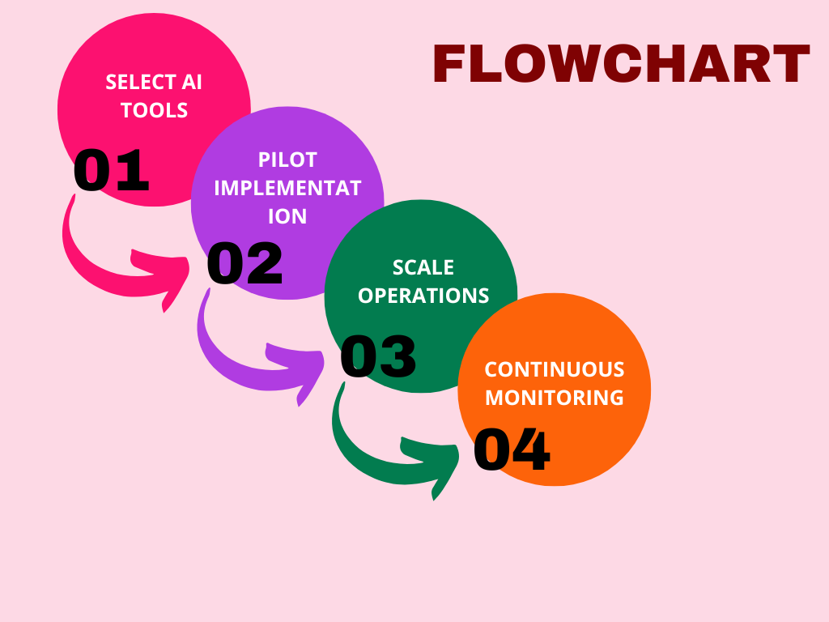

Fig 2: 4.1 Startups' AI Integration Framework

Figure 2 displays a systematic framework that helps startups adopt AI technologies in a systematic way. The initiative starts with a clear business need identification to ensure that AI adoption is problem-based and not technology-based. After the need has been identified, the subsequent step is to identify the most appropriate AI tool or platform that aligns with organizational objectives. This is followed by pilot implementation, where scaled-down trials validate performance and feasibility. The scaling operations phase focuses on spreading successful pilots throughout the organization to realize efficiency and innovation. Lastly, ongoing monitoring is used to ensure that AI systems continue to be relevant, accurate, and ethically correct over time. As seen in Fig. 2, this sequence guarantees that startups implement AI in a strategic, sustainable, and scalable way.

4.2 Case Studies: Successful AI-Driven Entrepreneurial Models

A few case studies demonstrate how AI integration turns startups into industry disruptors. For instance, AI-powered e-commerce companies leverage predictive analytics to offer personalized recommendations, enhancing customer retention and sales. In the same vein, health-tech startups utilize AI-driven diagnostic tools to offer quicker and more precise medical assessments. These start-ups show how AI generates concrete value for customers and markets (Zhao & Chen, 2023).

Moreover, companies that integrate AI into their platforms obtain scalability and differentiation benefits. For example, virtual platforms that have recommendation engines and fraud detection algorithms perform better than their competitors by delivering safer and more personalized user experiences. These illustrations show how entrepreneurs can apply AI strategically to construct robust growth models (Dwivedi et al., 2022).

5 AI and Innovation in Startups

Innovation is the lifeblood of an entrepreneur: AI accelerates the process of innovation, extending it to the domain of startups. Using AI, startups design disruptive solutions in healthcare, finance, mobility, and sustainability. In other words, it is not only about product design; it also caters to service delivery, customer engagement, and reinvention of business models. AI empowers startups to experiment fast, validate hypotheses, and scale solutions all at once. Another perspective from scholars is that innovation with AI enables startups to surpass the traditional impediments of meager resources by giving them insightful and predictive views of past-gained data. For entrepreneurs, AI is a creative partner and efficiency enabler that ensures they can take the lead in highly competitive, fast-moving markets. Hence, AI is the key driver of disruptive innovations and sustainable growth in entrepreneurial ecosystems.

5.1 Artificial Intelligence and Disruptive Innovation in Startups

Startups thrive on disruptive innovation, and AI has become a central driver in enabling this. By leveraging machine learning models, entrepreneurs can identify unmet customer needs and design products that disrupt established industries. For example, AI-enabled financial startups have outpaced traditional banks by offering faster loan approvals and personalized services. This highlights AI’s power to fuel radical change and create competitive asymmetry in markets (Christensen et al., 2020).

In addition to individual products, AI also reshapes service provision by making firms more responsive and dynamic. Startups are able to use algorithms that learn from customer interactions in real time, hence perfecting offerings in real time. This not only speeds up innovation but also enhances customer trust and loyalty. In the end, AI gives entrepreneurs the capacity to scale disruption fast, making startups central disruptors in the digital economy (Giones & Brem, 2021).

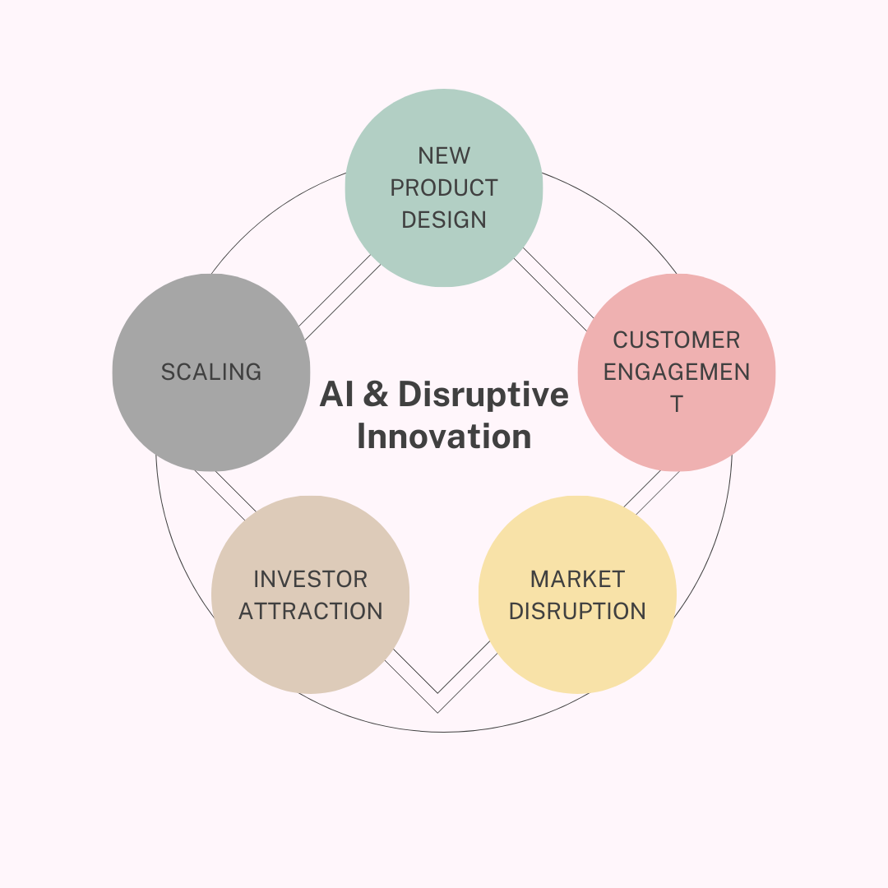

Fig 3: 5.1 AI as a Driver of Disruptive Innovation

Figure 3 illustrates the cyclical and ongoing nature of AI in facilitating disruptive innovation in startups. The cycle starts with new product design, where AI increases creativity and efficiency in crafting innovative solutions. This results in better customer engagement through customized experiences and services. This engagement, in turn, spurs market disruption, disrupting established players and redefining industry norms. The innovation that follows captures the attention of investors, giving startups the capital they need to expand. Lastly, scaling allows for these innovations to find their way into wider markets, making lasting impressions. As depicted in Fig. 3, these phases make up a never-ending loop in which every step bolsters the other, showing how AI is not only a tool, but also a catalyst for enduring disruption in entrepreneurial ecosystems.

5.2 Entrepreneurial Approaches to Disruption

Entrepreneurs leverage AI not just to create technological disruption but also as a vehicle for reimagining business models. Startups apply AI to construct platform-based ecosystems, where data and users interact to generate new streams of value. AI-powered logistics platforms, for instance, optimize supply chains that conventional companies are unable to replicate. This type of disruption revolutionizes the way resources are distributed and how firms scale (Eisenmann et al., 2021).

Disruption also calls for risk-taking and adaptability. Entrepreneurs who integrate AI into iterative strategies—pivoting, feedback, and testing—attain greater resilience against market upheaval. The ability to leverage AI as an experiment tool and agile redesign ensures that startups develop more quickly than their peers, internalizing disruption as a strategic tenet (Nambisan, 2021).

  - 📊 Table 5 : Entrepreneurial Approaches to Disruption

Approach | AI Contribution
Platform Ecosystems | Data-driven scalability
Agile Experimentation | Rapid testing & iteration
Supply Chain Optimization | Predictive analytics
Personalized Services | NLP & recommendation tools
Market Entry Strategies | AI-based risk assessment

Table 5 shows various entrepreneurial strategies to creating market disruption and how AI supports them. As indicated in Table 5, platform ecosystems take advantage of data-driven scalability, which enables startups to expand quickly on the basis of network effects. Agile experimentation uses AI to create fast testing and iteration, minimizing risks and speeding up innovation cycles. Supply chain optimization is facilitated by predictive analytics, which allows entrepreneurs to predict demand, minimize costs, and maximize efficiency. Customized services become possible through NLP and recommendation systems, which improve customer interaction and satisfaction. Lastly, AI-based risk assessment fortifies market entry strategies with opportunities and hedging against uncertainty. The following table shows how disruption in entrepreneurship is no longer coincidental but is purposefully developed with the intelligent use of AI.

6 Human-Centric and Ethical AI Leadership

As AI adoption accelerates, entrepreneurs must balance the technological possibilities with human values and ethics. Human-centered AI leadership speaks to the design and deployment of AI systems to respect human rights, build trust, and promote inclusivity. For entrepreneurs, this means ensuring transparency in algorithms and their decision-support systems, impartiality, and AI solutions that carry out activities that enhance rather than diminish human agency. Ethical leadership in AI-driven ventures also entails being held accountable by their stakeholders, regulators, and customers who are, today, increasingly concerned with responsible innovation. Scholars argue human-centered frameworks can be used for entrepreneurs as a guiding principle to capture the benefits of AI while managing its risks. This means that sustainable entrepreneurship is increasingly recognized not only as endorsing financial performance but also in building trust and legitimacy within AI-enabled ecosystems

6.1 Human-Centric AI Leadership

Leaders need to stay committed to human-centered strategies as AI redefines entrepreneurship. Human-centered AI is all about being transparent, fair, and inclusive, such that algorithms support and complement human decision-making. Entrepreneur-led startups that focus on ethics and empathy in AI development create greater trust with customers and stakeholders (Floridi & Cowls, 2022).

The leaders who apply human-centered practices also develop long-term robustness. By emphasizing responsible AI, they are compliant with regulations and reduce the risks of reputational damage. This establishes a pillar for sustainable innovation in which technology benefits people instead of replacing them. This kind of leadership achieves balance between efficiency and responsibility, ensuring both economic and social relevance (Jobin et al., 2019).

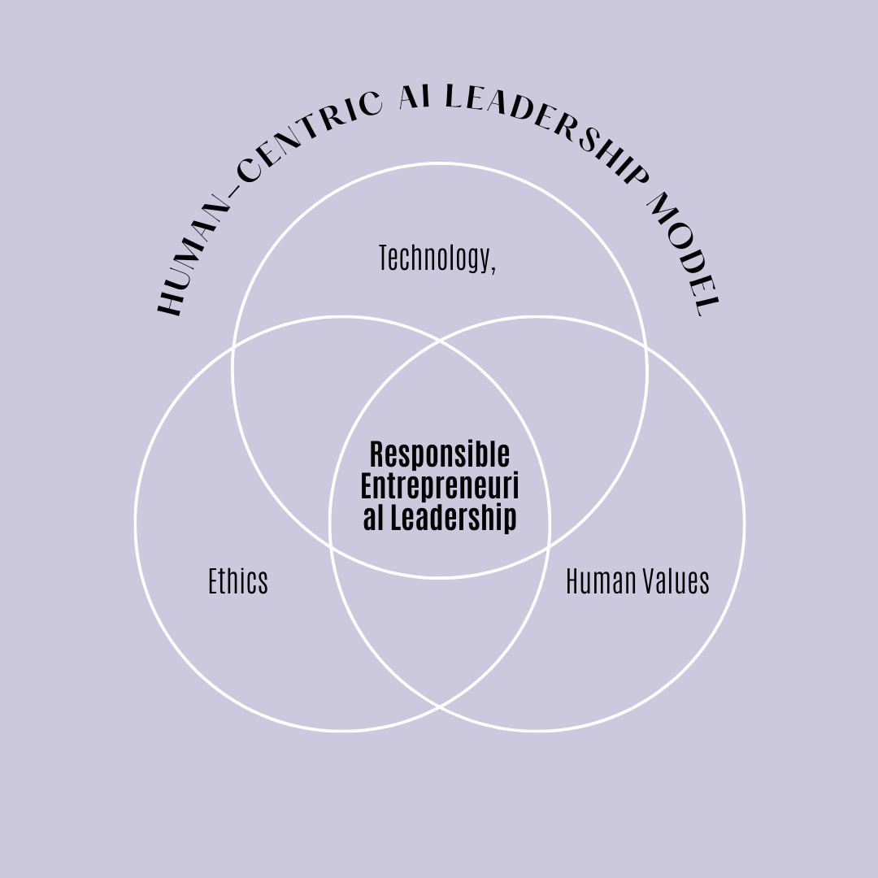
Fig 4 : 6.1 Human-Centric AI Leadership Model

Figure 4 calls out the human-focused AI model of leadership, which combines technology, ethics, and human values to achieve balanced and responsible innovation. Technology focuses on utilizing AI capabilities to improve business processes and competitiveness. Ethics enforces that AI take-up is equitable, transparent, and accountable, avoiding abuse and harm to society. Human values focus on empathy, inclusivity, and the well-being of stakeholders while keeping people at the forefront of technology advancements. The intersection of these three as seen in Fig. 4 is "Responsible Entrepreneurial Leadership," which guarantees that startups are able to tap into AI for both profitability and sustainable and ethical development. This model is focused on visionary leaders who are capable of bringing innovation together with responsibility.

6.2 Ethical Considerations in AI Entrepreneurship

Entrepreneurs embedding AI need to contend with ethical issues like algorithmic bias, privacy intrusions, and undisclosed decision-making. AI recruitment software that inadvertently discriminates, for example, emphasizes the need for fairness and accountably within startups. Mitigating these risks is pivotal to establishing trust and gaining long-term adoption (O'Neil, 2016).

Ethical entrepreneurship also entails proactive processes like algorithmic audits, open data policies, and engaging stakeholders. Startups that adopt such practices not only reduce risks but also stand out as reliable innovators. As customers become increasingly ethical aware, responsible AI leadership is a competitive edge in itself (Mittelstadt, 2021).

7 Data-Driven Decision Making in Entrepreneurship

Data would be the new money in entrepreneurship, and AI changes how data informs decisions. Entrepreneurs following data-driven strategies might gain a competitive advantage by turning raw information into actionable knowledge. These systems do this by collecting data automatically, identifying complex patterns, and then predicting market trends with great precision. Decision-making based on data allows fewer uncertainties, greater resource efficiency, and better identification of emerging consumer needs. Studies show that organizations passing down decisions by data techniques are more innovative and exhibit operational levels higher than their competitors. Especially for startups, where decisions are made fast and are high-stakes, the AI analytics serve to guide in making decisions both efficiently and innovatively, establishing data in this respect as the backbone of entrepreneurial success.

7.1 Data's Role in Entrepreneurial Decision Making

In contemporary entrepreneurship, data is the most prized resource for making informed decisions. Analytics driven by artificial intelligence enable startups to convert raw data into insights that inform strategies for marketing, finance, and operations. Data-driven models adopted by entrepreneurs minimize uncertainty and make more confident decisions (Provost & Fawcett, 2013).

In addition, AI facilitates decision-making in real-time with dynamic dashboards and forecast tools. This capability gives startups the leverage to change strategies in real-time as they respond to changes in the market, an agility that established companies cannot match. As markets continue to grow more data-intensive, the capability to extract value from AI-based insights will determine entrepreneurial success (Davenport, 2018).

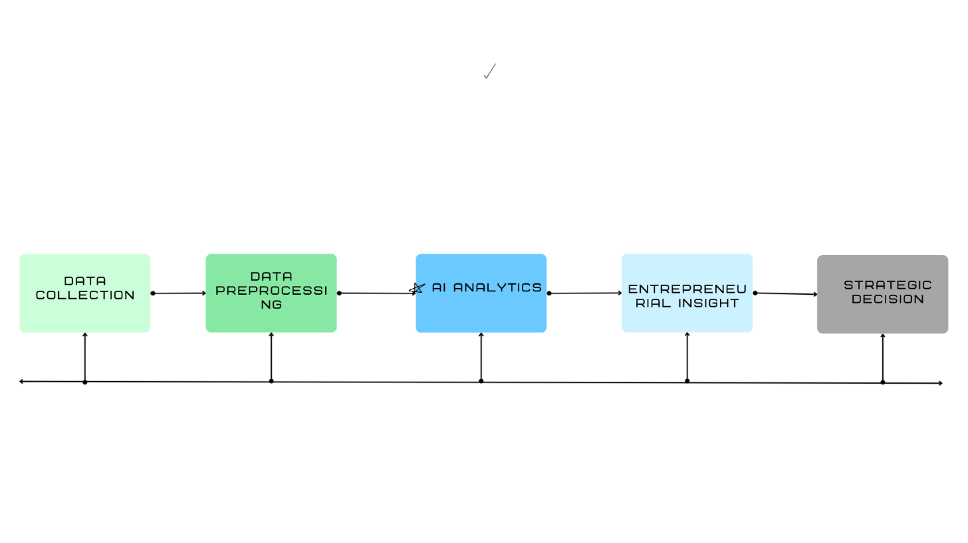
Fig 5 : 7.1 Data-Driven Decision-Making Process

Figure 5 summarizes the chronological process of data-driven decision-making that enables entrepreneurs to take strategic and well-informed decisions. The process starts with data collection, in which relevant and dependable information is collected from internal and external sources. This is followed by data preprocessing, where cleaning, structuring, and data preparation for analysis are done. The AI analytics phase runs sophisticated algorithms to detect patterns, trends, and buried knowledge. Entrepreneurial insight occurs when these analysis results are then interpreted within the business opportunity and risk framework. Lastly, the process ends in strategic decision-making, where data-driven insights guide key decisions on product creation, market expansion, and resource deployment. As shown in Fig. 5, this process illustrates how AI converts raw information into actionable intelligence, enhancing entrepreneurial decision-making

7.2 AI Analytics Tools for Entrepreneurs

Businesspersons utilize diverse sets of AI tools for making decisions, such as predictive modeling, natural language processing, and machine learning platforms. They aid in finding customer preferences, pricing optimization, and efficient supply chain management. Low-cost platforms like Google AI and AWS SageMaker enable analytics to be used even by small enterprises (Jordan & Mitchell, 2015).

The incorporation of these technologies into business processes increases competitiveness. For instance, sentiment analysis allows startups to quantify brand reputation, while predictive analytics enhances inventory planning. By utilizing these technologies, entrepreneurs not only grow more efficient but also gain richer relationships with their markets (Chui et al., 2018).

  - 📊 Table 5 : AI Analytics Tools for Entrepreneurs

Tool/Platform | Application
Google AI | Predictive modeling
AWS SageMaker | Machine learning training
IBM Watson | NLP & sentiment analysis
Tableau (with AI) | Data visualization
Microsoft Azure AI | Forecasting & optimization

Table 6 points to some of the important AI-driven tools and platforms that aid entrepreneurs in leveraging data for strategic decision-making. Table 6 illustrates that Google AI aids predictive modeling with insights into customer behavior and future trends. AWS SageMaker offers strong machine learning training, which helps startups build and deploy models at scale. IBM Watson focuses on natural language processing and emotion detection, allowing entrepreneurs to better hear what customers need and how they feel. Tableau, with the addition of AI capabilities, facilitates data visualization, allowing decision-making on complex sets of data to become more accessible. Microsoft Azure AI assists forecasting and optimization, which enables companies to enhance efficiency and accuracy in planning. This chart highlights that having access to various AI analytics tools gives entrepreneurs actionable intelligence, which encourages innovation and competitiveness.

8 Building AI readiness Entrepreneurial Teams

Even if the integration of AI projects is successful, people still matter. Thus, entrepreneurs must build teams qualified with the forethoughts and agility necessary for an AI-enabled environment. This includes recruiting and training for areas encompassing data analytics, AI ethics, and digital strategy while also fostering an organizational culture that encourages innovation and adaptable change. Scholars also emphasize interdisciplinarity — combining technical competence with business expertise and leadership. AI-ready teams are those able to accept rapid technological change, test out new ideas, and incorporate AI into business processes, thus offering a certain degree of flexibility. For the entrepreneur, fostering such teams will spice up the sustainability, scalability, and organizational business goals with the AI adoption so that in an AI-driven business, people strategy becomes as important as the technology strategy.

8.1 Creating Interdisciplinary Teams

AI-based startups need teams that bring together technical know-how along with business and leadership abilities. Startups need to hire data scientists, software engineers, and ethicists while also encouraging an overlap with marketing and strategy experts. This interdisciplinary combination ensures that AI integration is both technically feasible and market-relevant (Edmondson & Harvey, 2017).

Besides, various teams promote innovation through diverse viewpoints. Various studies establish that heterogeneous teams are better placed to discover innovative solutions and minimize biased decision-making. In startup companies, the composition of AI-ready teams is as much a cultural affair as it is technical expertise (Page, 2019).

8.2 Training and Upskilling in AI Readiness

AI adoption is only viable if teams are consistently upskilled. Business owners need to invest in training schemes that teach staff about AI ethics, data management, and new technologies. Online platforms like Coursera and edX have made learning easier for startups (Brynjolfsson & McAfee, 2017).
Upskilling also encourages flexibility, making teams ready to cooperate with AI systems instead of competing against them. By cultivating a culture of continuous learning, entrepreneurs make their teams versatile and able to adopt new AI applications as they change (Bughin et al., 2018).

9. AI for Business Growth and Market Engagement

Business growth and market engagement have been revolutionized by AI. For entrepreneurs, AI technology offers highly customized marketing, forecasting customer engagement, and dynamic pricing models for increasing revenue. Businesses are able to understand consumer behavior at scale with the help of AI insights, customizing products and services to address changing requirements. Furthermore, AI facilitates market expansion by uncovering overlooked customer segments and maximizing digital campaigns. Research finds that companies embracing AI in marketing get higher customer loyalty, brand distinction, and revenue increase. For new companies, it can even out the playing field so they could compete with bigger companies through innovation-based growth and more intelligent customer engagement strategies.

9.1 Marketing and Customer Interaction through Artificial Intelligence

Artificial intelligence has revolutionized entrepreneurial marketing by enabling hyper-personalization and predictive targeting. Startups now use AI-enabling tools to segment markets, analyze customer behavior, and offer custom experiences. For instance, recommendation engines on shopping websites significantly improve conversion rates by tailoring products to consumers (Shankar, 2018).

Moreover, AI enhances customer engagement with chatbots and virtual assistants available 24/7. Not only is this economical, but it also builds closer relationships with customers. Marketing practitioners who use AI for marketing derive their competitive advantage by combining efficiency and personalization (Luo et al., 2021).

9.2 AI-Enabled Customer Relationship Models

Artificial intelligence (AI) powered customer relationship management (CRM) systems allow entrepreneurs to predict churn, identify upsell opportunities, and offer proactive service. Startups are increasingly leveraging AI to combine CRM with social media, providing an integrated view of customer activity (Chatterjee et al., 2020).

These AI-based systems also reduce manpower, enabling entrepreneurial teams to focus more on innovation and customer experience. With the further development of AI-based CRMs, they will increasingly lay the groundwork for how startups maintain loyalty and growth (Nguyen & Simkin, 2022)

10. AI and Sustainable Business Practices

Over the last few years, AI has also emerged as a means to promote sustainability in entrepreneurship. From energy consumption optimization in business to product design for environmental sustainability, AI enables entrepreneurs to balance growth with environmental sustainability. Green AI practices include AI-enabled predictive maintenance for waste minimization, intelligent agriculture for optimized resource utilization, and carbon footprint tracking AI models. Researchers posit that "Green AI" is critical in balancing economic performance with environmental management, particularly with growing regulatory and consumer demands for sustainability. For founders, integrating sustainability into AI strategy not only enhances brand equity but also identifies opportunities in nascent green economies, making sustainability both a strategic and ethical necessity in AI-powered entrepreneurship.

10.1 Leadership Agility in the Age of AI

Entrepreneurial leadership in today's age demands agility—the ability to quickly change strategies when responding to AI-driven market dynamics. Agile leaders employ incremental learning and quick adaptation, allowing startups to respond to opportunities ahead of the players (Rigby et al., 2016).

AI increases leadership flexibility with real-time information and projections, allowing leaders to respond with speed and confidence. Entrepreneurs adopting this mindset become more resilient and competitive in uncertain markets (Joiner, 2019).

10.2 Adaptive Strategies for Entrepreneurs

AI allows entrepreneurs to develop responsive plans that respond instantaneously to shifting situations. For example, companies can use AI to monitor consumer sentiment and make changes in marketing initiatives real-time. Such responsiveness keeps companies up to date with market requirements (Eisenhardt & Martin, 2000).

Adaptive practices are also used in managing resources. By using AI forecasting, entrepreneurs make their supply chains and fiscal budgeting leaner and more sustainable through streamlined operations. These practices show how AI enables strategic agility in startups (Teece et al., 2016).

11. Future of AI-Enabled Entrepreneurship

The entrepreneurial future will be more and more shaped by the integration of AI with business ecosystems. New trends like generative AI, autonomous decision-making systems, and AI-driven innovation platforms are shaping entrepreneurial opportunities. Researchers forecast that AI will further reduce barriers to entry for new businesses through cost minimization of experimentation, improved scalability, and the creation of new digital markets. New regulations, workforce changes, and changing customer expectations in AI environments will also pose challenges to entrepreneurs. Entrepreneurial leadership will need to be nimble, future-oriented, and geared for lifelong learning to stay ahead in the AI-facilitated global economy.

11.1 Future Emerging Trends in AI for Entrepreneurship

The future of entrepreneurship will be shaped by the developments in generative AI, autonomous decision-making, and quantum computing. Generative AI, for instance, will enable startups to produce products and marketing materials at record speed, reducing time-to-market. These trends will also lower entry barriers and unlock new innovation potential (Kaplan & Haenlein, 2020).

However, the same developments are also accompanied by uncertainty. Small businesses must prepare for regulatory changes, ethics disputes, and shifting consumer attitudes. Those who lead the way in these new technologies will have long-term advantage in digital environments (Brynjolfsson & McAfee, 2021).

11.2 Ready for the Next Generation of AI Entrepreneurship

Entrepreneurs need to cultivate ongoing learning and scenario planning in order to prepare themselves to deal with the evolving AI landscape. Scenario-based strategies allow leaders to expect potential disruptions and devise strategies accordingly. Preparation reduces risks associated with technological ambiguity (Schoemaker, 2020).

In addition, engagement with universities and research institutions can help startups remain at the leading edge of AI. Through such partnerships, entrepreneurs are exposed to the latest developments while planning responsible innovation pathways (Chesbrough, 2020).

12.0 Conclusion

AI deployment in entrepreneurship is a revolutionary shift in venture working, innovation, and growth. From enabling disruption innovation to fostering human-centered leadership, AI has transformed the entrepreneurial process. Startups that implement AI not only gain competitive advantages but also shape the future of sectors (Dwivedi et al., 2021).

But success will depend on balancing technological ambition with accountability. Business leaders must turn ethical imperatives, interdisciplinary collaboration, and adaptability into their central agendas for ensuring sustainable development. When AI strategies are human-centered, startups can build both economic success and social trust, so AI is both a tool of enterprise but a foundation of entrepreneurial leadership (Kraus et al., 2022).

REFERENCES

AWS. (2023). Human-in-the-loop and human-centric AI integration for startups. AWS Whitepaper.

Brynjolfsson, E., & McAfee, A. (2017). Machine, platform, crowd: Harnessing our digital future. W.W. Norton & Company.

Brynjolfsson, E., & McAfee, A. (2021). The future of work in the AI age. MIT Press.

Bughin, J., Seong, J., Manyika, J., Chui, M., & Joshi, R. (2018). Skill shift: Automation and the future of the workforce. McKinsey Global Institute.

Chatterjee, S., Rana, N. P., Tamilmani, K., & Sharma, A. (2020). Adoption of AI in CRM: Opportunities and challenges. Journal of Strategic Marketing, 28(2), 152–170.

Chesbrough, H. (2020). Open innovation and entrepreneurial ecosystems. Oxford University Press.

Christensen, C. M., Raynor, M. E., & McDonald, R. (2020). Disruptive innovation in the age of AI. Harvard Business Review, 98(2), 44–53.

Chui, M., Harryson, M., Manyika, J., Roberts, R., & Chung, R. (2018). Notes from the AI frontier: Applications and value of deep learning. McKinsey Global Institute.

Davenport, T. H. (2018). Analytics at work: Smarter decisions, better results. Harvard Business Press.

Dwivedi, Y. K., Hughes, L., & Kumar, V. (2021). Artificial intelligence in business: Research agenda and implications. International Journal of Information Management, 57, 101–104.

Dwivedi, Y. K., Hughes, L., Ismagilova, E., et al. (2022). Artificial intelligence-enabled business models: A systematic review. Technological Forecasting and Social Change, 170, 120–135.

Edmondson, A. C., & Harvey, J. F. (2017). Cross-boundary teaming for innovation: Integrating research on teams and knowledge in organizations. Organization Science, 28(3), 331–354.

Eisenhardt, K. M., & Martin, J. A. (2000). Dynamic capabilities in markets of change. Strategic Management Journal, 21(10–11), 1105–1121.

Eisenmann, T., Parker, G., & Van Alstyne, M. W. (2021). Platform strategies and the role of AI in scaling startups. MIT Press.

European Commission. (2023). The EU AI Act: Regulation and risk-based approach. Publications Office of the EU.

EY. (2023). Business implications of the EU AI Act for entrepreneurial ventures. EY Insights.

Floridi, L., & Cowls, J. (2022). A unified framework for AI ethics and human-centered leadership. AI & Society, 37(1), 5–17.

Giones, F., & Brem, A. (2021). Digital technologies and radical business model innovation. Technological Forecasting & Social Change, 166, 120–138.

Harvard Business School Online. (2023). Four characteristics of AI-driven business models. HBS Online Insights.

ISACA. (2022). Artificial intelligence adoption and risk management. ISACA Research Report.

Jobin, A., Ienca, M., & Vayena, E. (2019). The global landscape of AI ethics guidelines. Nature Machine Intelligence, 1(9), 389–399.

Joiner, B. (2019). Leadership agility: Leveraging AI for adaptive strategies. Leadership Quarterly, 30(2), 143–156.

Jordan, M. I., & Mitchell, T. M. (2015). Machine learning: Trends, perspectives, and prospects. Science, 349(6245), 255–260.
J.P. Morgan. (2023). The AI startup primer: Adoption trends in emerging firms. J.P. Morgan Research.

Kaplan, A., & Haenlein, M. (2020). Rulers of the world, unite! The challenges of generative AI. Business Horizons, 63(1), 37–50.

Kaufman Rossin. (2023). Strategic integration of AI in entrepreneurial leadership. Kaufman Rossin Report.

Kraus, S., Roig-Tierno, N., & Bouncken, R. B. (2022). Artificial intelligence in business model innovation: A review. Review of Managerial Science, 16(5), 117–145.

Kraus, S., Roig-Tierno, N., & Bouncken, R. B. (2022). AI and sustainable entrepreneurship: A systematic review. Journal of Cleaner Production, 366, 132–149.

Luo, X., Tong, S., Fang, Z., & Qu, Z. (2021). AI-powered customer engagement in startups. Journal of Business Research, 124, 366–374.

Menlo Ventures. (2023). From pilots to production: Enterprise AI adoption insights. Menlo Ventures Report.

Mittelstadt, B. (2021). Principles of AI ethics for responsible entrepreneurship. Journal of Business Ethics, 170(1), 1–16.

Nambisan, S. (2021). Digital entrepreneurship and the dynamic nature of innovation. Journal of Business Venturing, 36(5), 106–120.

Nguyen, B., & Simkin, L. (2022). Customer relationship management in the AI age. Routledge.

O’Neil, C. (2016). Weapons of math destruction: How big data increases inequality and threatens democracy. Crown Publishing.

Page, S. (2019). The diversity bonus: How great teams pay off in the knowledge economy. Princeton University Press.

Provost, F., & Fawcett, T. (2013). Data science for business: What you need to know about data mining and data-analytic thinking. O’Reilly Media.

Rigby, D. K., Sutherland, J., & Noble, A. (2016). Agile at scale. Harvard Business Review, 94(3), 88–96.

Schoemaker, P. J. H. (2020). Scenario planning in the age of AI. MIT Sloan Management Review, 61(2), 35–41.

Shankar, V. (2018). How artificial intelligence (AI) is reshaping retailing. Journal of the Academy of Marketing Science, 46(2), 179–190.
Teece, D. J., Peteraf, M. A., & Leih, S. (2016). Dynamic capabilities and organizational agility. California Management Review, 58(4), 13–35.

The New Yorker. (2023). The AI adoption J-curve and its implications for business productivity. The New Yorker Tech Reports.

Zhao, L., & Chen, H. (2023). AI in business model innovation: Case-based evidence. Sustainability, 15(3), 141–158.

